**Watching files with nodemon**

When developing locally, you'll oftentimes make small changes to your code, save them, and then want to observe the results on your local server. If you are running your server with the command node server.js, your source files will be read in once, before the server starts. If you make changes to your source code and want to see them, you'd have to manually stop your server (by running Ctr-c from the command line terminal it's running from) and then restart it in order for the changes to be picked up.

This proves to be rather cumbersome. Fortunately we can use the NPM package [nodemon](https://github.com/remy/nodemon" \t "_blank) to automatically reload apps whenever source files are changed and saved. Let's see how.

First, from the command line (Git-Bash if you're on windows), install nodemon globally by running npm install -g nodemon. Since we'll only be using nodemon in our local development environment, we don't need to install it as a specific dependency for each project.

Next, clone [this repo](https://github.com/Thinkful-Ed/node-nodemon-demo), then cd node-nodemon-demo and run npm install.

After the dependencies install, start the server with npm start, then visit localhost:8080 in a browser. You'll see that our app returns the message "hello world".

Next, open node-nodemon-demo/server.js in your text editor. Change line 5 from const message = 'Hello world'; to const message = 'bonjour le monde'; and save your changes.

Now back in Chrome, refresh localhost:8080, and you get... exactly what we had before. As we said, in order for these changes to go live, we have to manually restart the server. You can try doing this by running Ctrl-c from the command line terminal running your app, followed by npm start to restart the server. If you refresh your browser at localhost:8080, you should now see our updated message bonjour le monde.

You can see how this would get annoying when you're iterating on an app and making lots of small changes.

Back in the command line terminal running your app, stop the app. Restart it using the command nodemon server.js. Then, back in your text editor, change line 5 from const message = 'bonjour le monde'; to const message = 'hola mundo'; and save your changes.

Back in Chrome, refresh localhost:8080 (you *do* still have to refresh in the browser). This time you should see the new message ("hola mundo"), even though we haven't restarted the server.

Also, have a look at the logs your server is outputting in the command line terminal. They should look something like this:

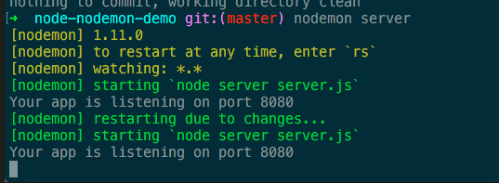

As you can see, nodemon prints a message that it has restarted the server when we save changes to our source files.

You can shut down your server with Ctrl-c as normal. Go ahead and delete this project from your computer as you won't be needing it again.

Moving forward, when you're developing locally, you can start your apps with nodemon server.js in order to restart the server on changes.